Cross-quantilogram: EURUSD and USDCHF
Method 20 / daily log returns / expanding quantiles / Alpari D1 full available history

Study setup
Logical pair: EURUSD , USDCHF
Broker symbols: EURUSD_i , USDCHF_i
Snapshot: 2026-11-03_majors_alpari_D1
Timeframe: D1
Matched return window: 1999-01-05 to 2026-11-02 (UTC bar dates)
Matched return count n: 7186
Dropped unfinished last bar dated 2026-11-03 UTC after a tick-volume check against the prior complete day.
Quantiles: expanding window, min history 252 days
tau in [0.05, 0.2]; k=0..10; headline tau=0.05, k=1
Complete matched rows (Excel): EURUSD-USDCHF_CQ_D1.xlsx
Complete matched rows (HTML table): EURUSD-USDCHF_CQ_D1_data.html

Method carried forward
The cross-quantilogram rho_tau(k) measures linkage among centered quantile-hit indicators of matched daily log returns of close, ln(close_t / close_t-1). Quotes are not inverted. At each date t, the tau-quantile uses only returns through t (expanding window) after a minimum history of 252 days. Hits are h_t = 1(r_t < q_t) - tau. rho_tau(k) is the normalized cross-product of h_x,t with h_y,t+k. Levels tau in {0.05, 0.20} and lags k=0..10 are pre-specified; headline is tau=0.05, k=1 both directions. Same-sample Pearson r is a side check. This is not causation and not a trading signal.

Results (headline)
rho_EURUSD->USDCHF(tau=0.05,k=1): 0.001043
rho_USDCHF->EURUSD(tau=0.05,k=1): 0.036562
rho_EURUSD->USDCHF(tau=0.20,k=1): 0.003178
rho_USDCHF->EURUSD(tau=0.20,k=1): 0.033769
Pearson r: -0.749204

CQ table (tau=0.05)
k | rho_EURUSD_to_USDCHF | n_EURUSD_to_USDCHF | rho_USDCHF_to_EURUSD | n_USDCHF_to_EURUSD
0 | -0.02114435 | 6935 | -0.02114435 | 6935
1 | 0.00104335 | 6934 | 0.03656181 | 6934
2 | 0.04543083 | 6933 | 0.05431055 | 6933
3 | 0.03654043 | 6932 | 0.05430005 | 6932
4 | 0.02320987 | 6931 | 0.02320987 | 6931
5 | 0.03236576 | 6930 | 0.02319902 | 6930
6 | 0.03680395 | 6929 | 0.04538845 | 6929
7 | 0.04124224 | 6928 | 0.01429713 | 6928
8 | 0.01898632 | 6927 | 0.03648695 | 6927
9 | 0.02787361 | 6926 | 0.02315565 | 6926
10 | 0.063456 | 6925 | 0.05866681 | 6925

Conclusion
Headline tau=0.05, k=1 for EURUSD and USDCHF: rho_EURUSD->USDCHF = 0.0010; rho_USDCHF->EURUSD = 0.0366. At tau=0.20, k=1: 0.0032 and 0.0338. Same-day tau=0.05 rho(k=0) = -0.0211. Pearson r = -0.7492. This is quantile-hit linkage, not a trading signal.

Charts
Daily closes

Daily log returns

Cross-quantilogram tau=0.05
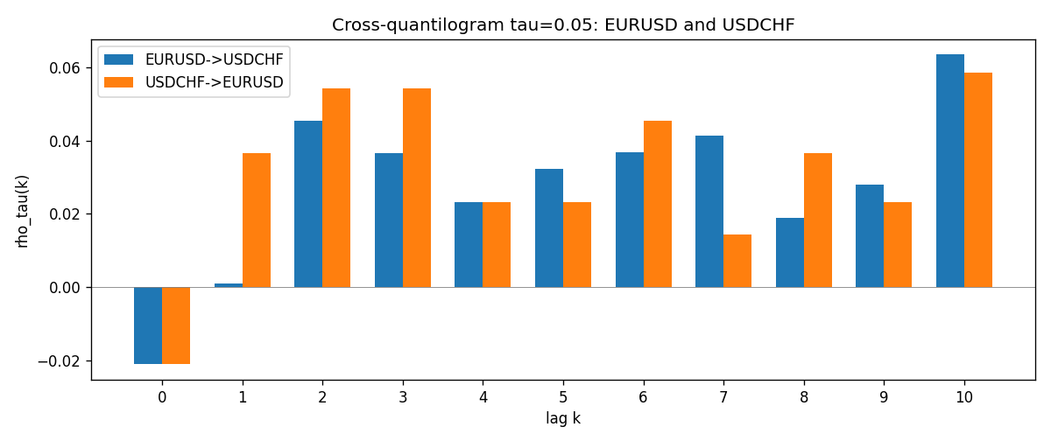

Data report
Matched rows and the CQ sheet are in the sibling Excel workbook named EURUSD-USDCHF_CQ_D1.xlsx. Embedding all rows as a Word table is impractical; this file holds column summaries and the first and last 15 matched rows.
Columns: time, EURUSD_open, USDCHF_open, EURUSD_high, USDCHF_high, EURUSD_low, USDCHF_low, EURUSD_close, USDCHF_close, EURUSD_tick_volume, USDCHF_tick_volume, EURUSD_spread, USDCHF_spread, EURUSD_real_volume, USDCHF_real_volume, EURUSD_log_return, USDCHF_log_return, EURUSD_h_t005, USDCHF_h_t005
Column summaries (matched calculation rows)
column | count | mean | std | min | 25% | 50% | 75% | max
EURUSD_open | 7186 | 1.181536 | 0.15083018 | 0.8272 | 1.086205 | 1.16621 | 1.29401 | 1.5995
USDCHF_open | 7186 | 1.0974503 | 0.25221737 | 0.72022 | 0.9205325 | 0.9899 | 1.23765 | 1.8219
EURUSD_high | 7186 | 1.1866696 | 0.15143104 | 0.8326 | 1.090285 | 1.17131 | 1.299445 | 1.6038
USDCHF_high | 7186 | 1.102742 | 0.25396197 | 0.73305 | 0.924775 | 0.99353 | 1.2422 | 1.8313
EURUSD_low | 7186 | 1.1765242 | 0.15015364 | 0.8227 | 1.0820725 | 1.16258 | 1.2885325 | 1.5865
USDCHF_low | 7186 | 1.0923313 | 0.25063382 | 0.08565 | 0.91721 | 0.98623 | 1.2315 | 1.8121
EURUSD_close | 7186 | 1.1815785 | 0.15080545 | 0.8267 | 1.0860875 | 1.166185 | 1.2941 | 1.5997
USDCHF_close | 7186 | 1.0974447 | 0.25212504 | 0.72025 | 0.920795 | 0.98995 | 1.237525 | 1.8217
EURUSD_tick_volume | 7186 | 103207.57 | 173534.06 | 218 | 9426 | 52774.5 | 99579.75 | 1471626
USDCHF_tick_volume | 7186 | 74325.102 | 113489.5 | 18 | 12800 | 40232.5 | 70435.25 | 858589
EURUSD_spread | 7186 | 19.339549 | 16.550572 | 0 | 8 | 12 | 20 | 50
USDCHF_spread | 7186 | 26.036877 | 24.695014 | 0 | 5 | 16 | 50 | 100
EURUSD_real_volume | 7186 | 4.0330482e+10 | 1.6691688e+11 | 0 | 0 | 0 | 0 | 3.6149665e+12
USDCHF_real_volume | 7186 | 2.3290849e+10 | 8.9127816e+10 | 0 | 0 | 0 | 0 | 1.9331921e+12
EURUSD_log_return | 7186 | -3.06e-06 | 0.00580427 | -0.03123819 | -0.00324267 | 0 | 0.00325778 | 0.03433183
USDCHF_log_return | 7186 | -6.921e-05 | 0.00659379 | -0.19545699 | -0.00335085 | 8.077e-05 | 0.003323 | 0.09051364
EURUSD_h_t005 | 6935 | -0.0166907 | 0.17945594 | -0.05 | -0.05 | -0.05 | -0.05 | 0.95
USDCHF_h_t005 | 6935 | -0.0166907 | 0.17945594 | -0.05 | -0.05 | -0.05 | -0.05 | 0.95
First 15 matched rows (selected columns)
time | EURUSD_log_return | USDCHF_log_return | EURUSD_h_t005 | USDCHF_h_t005
1999-01-05 | -0.0048360507 | 0.0039424743 | nan | nan
1999-01-06 | -0.011547966 | 0.013605652 | nan | nan
1999-01-07 | 0.0076280636 | -0.0093883841 | nan | nan
1999-01-08 | -0.010902799 | 0.011040268 | nan | nan
1999-01-11 | -0.007103287 | 0.0052963193 | nan | nan
1999-01-12 | 0.0045103728 | -0.0098275602 | nan | nan
1999-01-13 | 0.010845346 | -0.018259701 | nan | nan
1999-01-14 | 0 | -0.0024256692 | nan | nan
1999-01-15 | -0.010153245 | 0.01794228 | nan | nan
1999-01-18 | 0.0036256946 | -0.0031856384 | nan | nan
1999-01-19 | -0.00017235436 | -7.2518946e-05 | nan | nan
1999-01-20 | -0.0031939256 | 0.0072259871 | nan | nan
1999-01-21 | 0.0030215416 | -0.0038232689 | nan | nan
1999-01-22 | -0.0012075213 | -0.0001445609 | nan | nan
1999-01-25 | -0.0030251979 | 0.0024546976 | nan | nan
Last 15 matched rows (selected columns)
time | EURUSD_log_return | USDCHF_log_return | EURUSD_h_t005 | USDCHF_h_t005
2026-10-13 | 0.0037402957 | -0.0024955621 | -0.05 | -0.05
2026-10-14 | -0.0037582255 | 0.0029388325 | -0.05 | -0.05
2026-10-15 | 0.0056053107 | -0.0097855323 | -0.05 | -0.05
2026-10-16 | 0.0017724895 | -0.0036230826 | -0.05 | -0.05
2026-10-19 | -0.0025394633 | 0.0036351779 | -0.05 | -0.05
2026-10-20 | 0.0023881672 | -0.0026281224 | -0.05 | -0.05
2026-10-21 | -0.00032046717 | -0.00040027413 | -0.05 | -0.05
2026-10-22 | -0.0015949606 | -0.0048036381 | -0.05 | -0.05
2026-10-23 | -0.001338521 | 0.005652514 | -0.05 | -0.05
2026-10-26 | -0.0022706559 | 0.0018407959 | -0.05 | -0.05
2026-10-27 | -0.004152342 | 0.0026100526 | -0.05 | -0.05
2026-10-28 | 0.0022262927 | -0.0010142111 | -0.05 | -0.05
2026-10-29 | 0.0022571351 | -0.0048680164 | -0.05 | -0.05
2026-10-30 | -0.0011458446 | 0.00071594559 | -0.05 | -0.05
2026-11-02 | 0.002120569 | -0.0071459744 | -0.05 | -0.05

